GAYATRI VIDYA PARISHAD COLLEGE FOR DEGREE AND PG COURSES (A)



GAYATRI VIDYA PARISHAD COLLEGE FOR DEGREE AND PG COURSES (A)
DEPARTMENT OF ELECTRONICS & COMMUNICATION ENGINEERING
ENGINEERING & TECHNOLOGY PROGRAM
Rushikonda, Visakhapatnam-530 045 | website: www.gvpcdpgc.edu.in
(Approved by AICTE I Affiliated to Andhra University I Accredited by NAAC I ISO 9001:2015)

TITLE: IOT HOME AUTOMATION USING ESP32 AND BLYNK
1.INTRODUCTION:

In recent years, the Internet of Things (IoT) has become one of the most influential technologies in the field of electronics and communication. IoT enables everyday devices to connect to the internet, allowing them to send, receive, and process data. One of the most popular applications of IoT is home automation, where household electrical devices such as lights, fans, and appliances can be controlled remotely using smartphones, Wi-Fi, or cloud-based platforms. This project presents an IoT-based Home Automation System using the ESP32 microcontroller and Blynk IoT platform.
The ESP32 is a powerful Wi-Fi-enabled microcontroller capable of connecting to the internet and communicating with cloud servers. The Blynk platform allows users to create a mobile dashboard to control and monitor devices in real time.
The system demonstrated in this project controls two LEDs, which represent actual household appliances. These LEDs can be controlled using:
- Physical switches
- The Blynk IoT mobile application
This dual-mode control system shows how modern smart homes operate by combining manual and remote operation. The project also highlights the safety, reliability, and flexibility of connected home automation systems.

- OBJECTIVE:
The main objectives of this project are:
  - To design and implement a simple and low-cost IoT-based home automation system.
  - To remotely control home appliances using a smartphone via the Blynk IoT platform.
  - To implement manual control using physical push-button switches.
  - To synchronize physical switch states with the cloud system in real time.
  - To understand internet-based communication between ESP32 and Blynk cloud servers.
  - To demonstrate the concept of hybrid controlling—both physical and virtual.

- COMPONENTS USED:
The following components are required to build this project:
1. ESP32 Development Board
A Wi-Fi and Bluetooth-enabled microcontroller used to connect with the Blynk cloud.
  - LEDs (2 Units)
Used to represent two electrical loads (such as lamps or fans).
  - Push-button Switches (2 Units)
Used for manual/physical control of the loads.
  - Breadboard
For connecting circuits without soldering.
  - Jumper Wires / Copper Wires
Used to establish electrical connections.
  - USB Cable
Used to power the ESP32 and upload the program.
  - Blynk IoT Mobile Application
Used to control the devices via the internet.
  - Wi-Fi Network
Required to connect the ESP32 to the Blynk cloud.
This project uses only 3.3V low voltage, making it safe for beginners and academic demonstrations.

4.CIRCUIT DESCRIPTION:
The hardware connections for the system are simple and easy to implement. Each LED and switch is connected to a specific GPIO pin of the ESP32:
  - LED 1 → GPIO 13
  - LED 2 → GPIO 12
  - Switch 1 → GPIO 26 (INPUT_PULLUP)
  - Switch 2 → GPIO 25 (INPUT_PULLUP)
  - Ground (GND) of switches and LEDs connected to ESP32 GND
The LED pins are configured as OUTPUT, and the switches are configured as INPUT_PULLUP, meaning they remain HIGH when not pressed and read LOW when pressed.
How the Circuit Works
  - When a switch is pressed, the ESP32 detects a LOW input and toggles the LED state.
  - The ESP32 then updates the Blynk app with the new LED status.
  - When the user presses a button on the Blynk app, the ESP32 receives a virtual pin command and updates the LED state.
  - The physical switch will also reflect the change if pressed afterward.

5.WORKING PRINCIPLE:
The working of the system is based on continuous communication between the ESP32, the Blynk server, and the user’s smartphone.
  - The ESP32 connects to the local Wi-Fi network.
  - The Blynk application sends digital commands through the cloud server.
  - The ESP32 receives these commands and controls the LEDs (representing home appliances).
  - Physical switch inputs are also monitored using a periodic check.
  - When a physical switch is pressed, the ESP32:
    - Toggles the LED
    - Sends the updated state back to Blynk
6. This ensures real-time synchronization between physical and virtual switching.
This type of system is widely used in smart homes, automatic lighting systems, and remote appliance control systems.

CIRCUIT CONNECTION:
(HARDWARE)

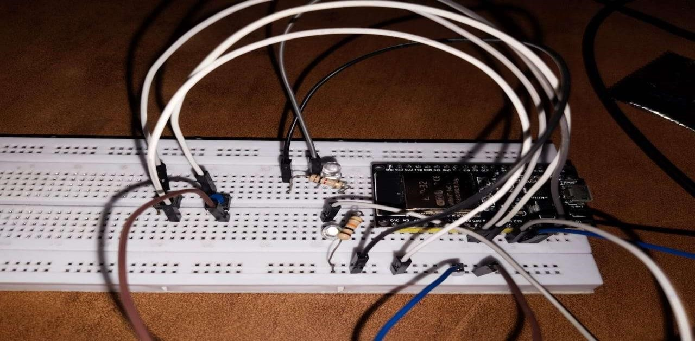

(SOFTWARE)
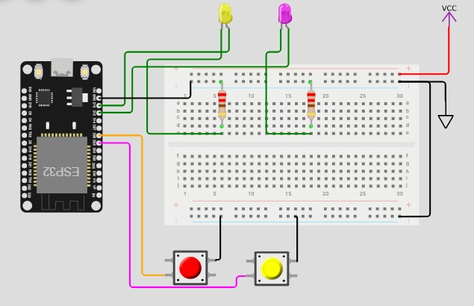

6.ARDUINO CODE USED IN THE PROJECT:

Below is the exact working code used in the project:
#define BLYNK_TEMPLATE_ID "TMPL3zLAwA-EB"
#define BLYNK_TEMPLATE_NAME "Home Automation 2"
#define BLYNK_AUTH_TOKEN "Your Auth Token"

#include <WiFi.h>
#include <WiFiClient.h>
#include <BlynkSimpleEsp32.h>

char auth[] = BLYNK_AUTH_TOKEN; char ssid[] = "Wokwi-GUEST";
char pass[] = "";

#define switch1_pin 26
#define switch2_pin 25
#define led1_pin 13
#define led2_pin 12

#define vpin_led1 V1
#define vpin_led2 V2

int led1_state = 0; int led2_state = 0;

BLYNK_CONNECTED() {
Blynk.syncVirtual(vpin_led1);
Blynk.syncVirtual(vpin_led2);
}

BLYNK_WRITE(vpin_led1) { led1_state = param.asInt();
digitalWrite(led1_pin, led1_state);
}

BLYNK_WRITE(vpin_led2) { led2_state = param.asInt();
digitalWrite(led2_pin, led2_state);
}

void setup() { Serial.begin(115200); pinMode(switch1_pin, INPUT_PULLUP); pinMode(switch2_pin, INPUT_PULLUP); pinMode(led1_pin, OUTPUT); pinMode(led2_pin, OUTPUT);

digitalWrite(led1_pin, LOW); digitalWrite(led2_pin, LOW);

Blynk.begin(auth, ssid, pass);
}

void loop() {
Blynk.run();
}

7.OUTPUT:
When the system is powered ON and connected:
- The ESP32 connects to the Wi-Fi network and Blynk cloud.
- The user can press buttons on the Blynk mobile app to turn ON/OFF LEDs.
- The physical switches can also control the LEDs manually.
- Any change made using physical switches is updated on the Blynk app and vice-versa.
- The result is a synchronized, real-time home automation system.
This project demonstrates how cloud-based home automation works in practical environments.

9.ADVANTAGES:
- Easy to implement
- Low cost
- Wi-Fi-based real-time control
- Dual control: physical + mobile app
- Can be expanded to 4, 8, or 16 appliances
- Cloud-based monitoring
- Safe low-voltage demonstration
- Highly reliable for home use

10.CONCLUSION:
This project successfully demonstrates a working IoT-based home automation system using ESP32 and Blynk IoT. It allows users to control devices both manually and remotely, offering convenience, safety, and modern automation capability. The ESP32 microcontroller, combined with Blynk, provides a cost-effective and scalable solution for implementing automation in homes and offices. The project serves as a foundation for more advanced systems, such as sensor-based automation, voice control, scheduling, or integrating real AC appliances through relays.

